The GLOCAL

COMELA 2021

The GLOCAL Conference on

Mediterranean and European Linguistic Anthropology 2021

(SCOPUS/ISI indexed)

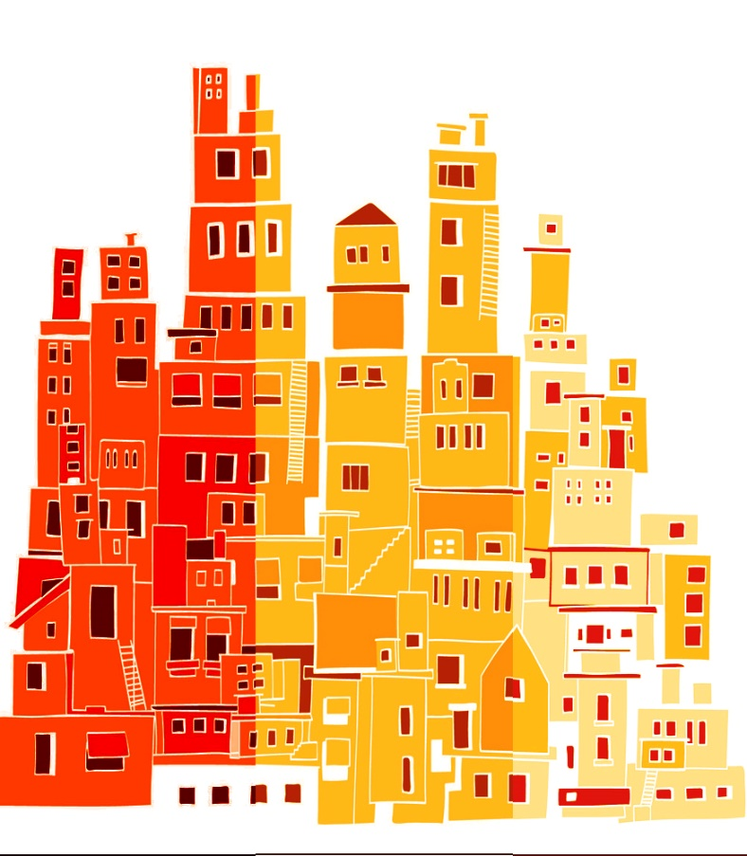

Bounded Languages … Unbounded
Περιορισμένες γλώσσεs … Απεριόριστες

July 21-24, 2021, Athens, Greece,

National and Kapodistrian University of

Athens

(co-host SOAS, University of London)

https://comela2021.uoa.gr

COVID-19 Extended Call

(Deadline March 10, 2021)

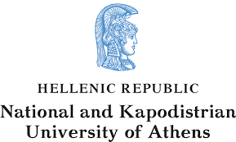
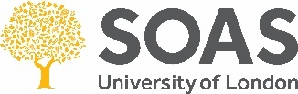
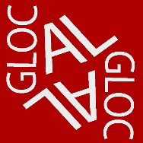

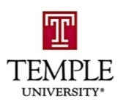
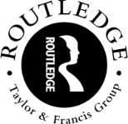

University of Hawai’i
University College London

Montclair State University
Temple University
Routledge Publishers Global

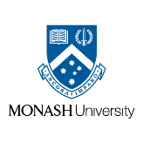
University of Kansas
Ohio State University
University of London
University of Illinois
Monash University
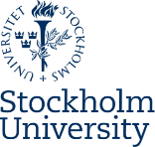
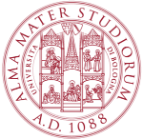
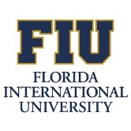
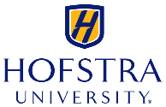

Stockholm University
University of Bologna
Florida International University

Texas Tech University
Hofstra University
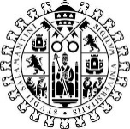
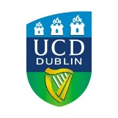
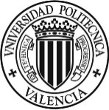
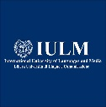
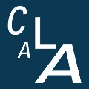

University College Dublin
University of Salamanca
IULM University
Polytechnic University of Valencia
The Conference on Mediterranean and European Linguistic Anthropology

CONTENTS

- Theme
- Conference format
- Location
- Speakers
- Publishing
- Dates
- Schedule
- Submissions
- Presentations
- Fees
- Indexing
- Scientific committees
- Affiliates
- COVID-19 Statement
- Contact information

Special Note
The GLOCAL is a Non-Profit Organization, and all publishing with The GLOCAL COMELA is FREE. The GLOCAL COMELA will always endorse a meritocracy system, thus refusing to adopt systems that require the implementation of paid fees. The GLOCAL COMELA sources funding and grants from funding agents to assist those exceptional academics who require funding to access Linguistics and Anthropology, and related fields, and who display exceptional talent in the field of Mediterranean and European Linguistic Anthropology

THEME

MAIN THEME

Bounded Languages … Unbounded
Περιορισμένες γλώσσες, Απεριόριστες
Politics of identity are central to language change. Here, linguistic boundaries rise and fall, motivating the ephemeral characteristics of language communities. The Mediterranean and European regions are replete with histories, with power struggles, uniquely demarcating nation, ethnicity, and community. For this, cultural and political identities, language ideologies, as well as the languages themselves, have sought boundedness, dynamics of which have indeed sought change over eons, through demographic movements, through geopolitics, through technological innovation. In a current era of technological advancement, transnational fluidity, intellectual power, capitalism, and new sexualities, then, we question, once again, the boundedness of language and identity, and ways in which to unbound languages and ideologies. More than before, we now increasingly pursue anthropological toil, so to innovate ways to locate these ideologies and their fluid boundaries, actively. We now need to increasingly unbind these languages, and their ideologies, so to arrive at progressive realizations, and to rectify, or at least see and move past, the segregations of old.
The GLOCAL COMELA 2021 theme, “Bounded languages… Unbounded”, encapsulates the ongoing struggle throughout Mediterranean and European regions. As the continuous tension between demarcation, and the concurrent legitimization, of languages, language ideologies, and language identities, enters an era where new modes of interactivity require language communities to take on roles super-ordinate to the past, flexible citizenship now operates within, and not only across, language communities, to unbind languages, and to create new boundaries, unlike those ever seen throughout history.
The GLOCAL COMELA 2021 invites work which addresses the shifting boundedness of Language Communities of the Mediterranean and Europe. Papers and posters should acknowledge and describe processes of language shape, change, and ideology, pertinent to social, cultural, political histories, and futures of Mediterranean and European regions, and by those working in Mediterranean and European regions.
Professor Achilleas G. Chaldaeakes
Chair
The GLOCAL COMELA 2021

THEME
MAIN STRANDS

- Anthropological Linguistics
- Applied Sociolinguistics
- Buddhist studies and discourses
- Cognitive Anthropology and Language
- Critical Linguistic Anthropology
- Ethnographical Language Work
- Ethnography of Communication
- General Sociolinguistics
- Islamic Studies and discourses
- Language, Community, Ethnicity
- Language Contact and Change
- Language, Dialect, Sociolect, Genre
- Language Documentation
- Language, Gender, Sexuality
- Language Ideologies
- Language Minorities and Majorities
- Language Revitalization
- Language in Real and Virtual Spaces
- Language Socialization
- Language and Spatiotemporal Frames
- Multifunctionality
- Narrative and Metanarrative
- Nonverbal Semiotics
- Oral Tradition
- Poetics
- Post-Structuralism and Language
- Semiotics and Semiology
- Social Psychology of Language
- Text, Context, Entextualization

CONFERENCE FORMAT

GENERAL PAPERS
Over 200
COLLOQUIA
Over 20
POSTER PRESENTATIONS
Over 30
METHODOLOGY / ANALYSIS WORKSHOPS
ELAR – Endangered Language Repository, SOAS
Several Academic Scholars on Linguistics, Anthropology, Sociolinguistics

TALKS
Whistle Community, Panagiotis Tsanavaris
Anthropological Association of Greece
Greek Society for Ethnology
Keynotes
Jan Blommaert
Alexandra Georgakopoulou
Dimitris Dalakoglou

ANTHROPOLOGY EXCURSION
Meteora Monastery
Diminnitsa Anthropological and Historical Village
CULTURAL PERFORMANCE
Likeio Eillinithon, Athens

CONFERENCE FORMAT

ANTHROPOLOGICAL EXHIBITIONS
Endangered Languages Projects
Ethnographic Projects
SOAS
10 global universities
DISPLAYS
Various Universities and Associations

PROCEEDINGS PUBLICATIONS
ISI / SCOPUS / AHCI / CPCI Indexed Proceedings book
SPECIAL ISSUES
Several special journal issues on highly tiered journals

LOCATION

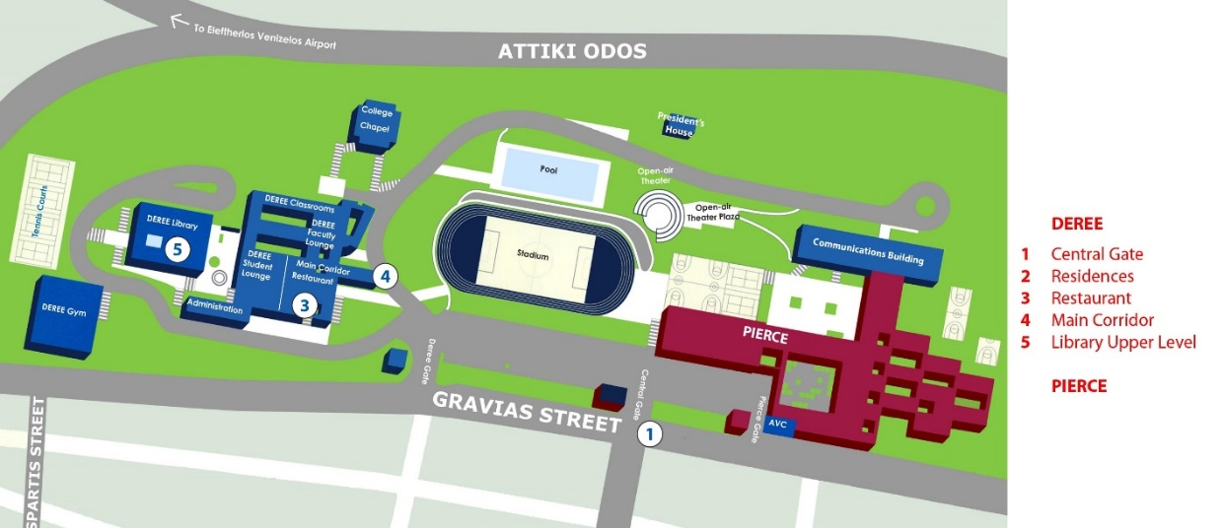
CAMPUS MAP

ROOM MAP
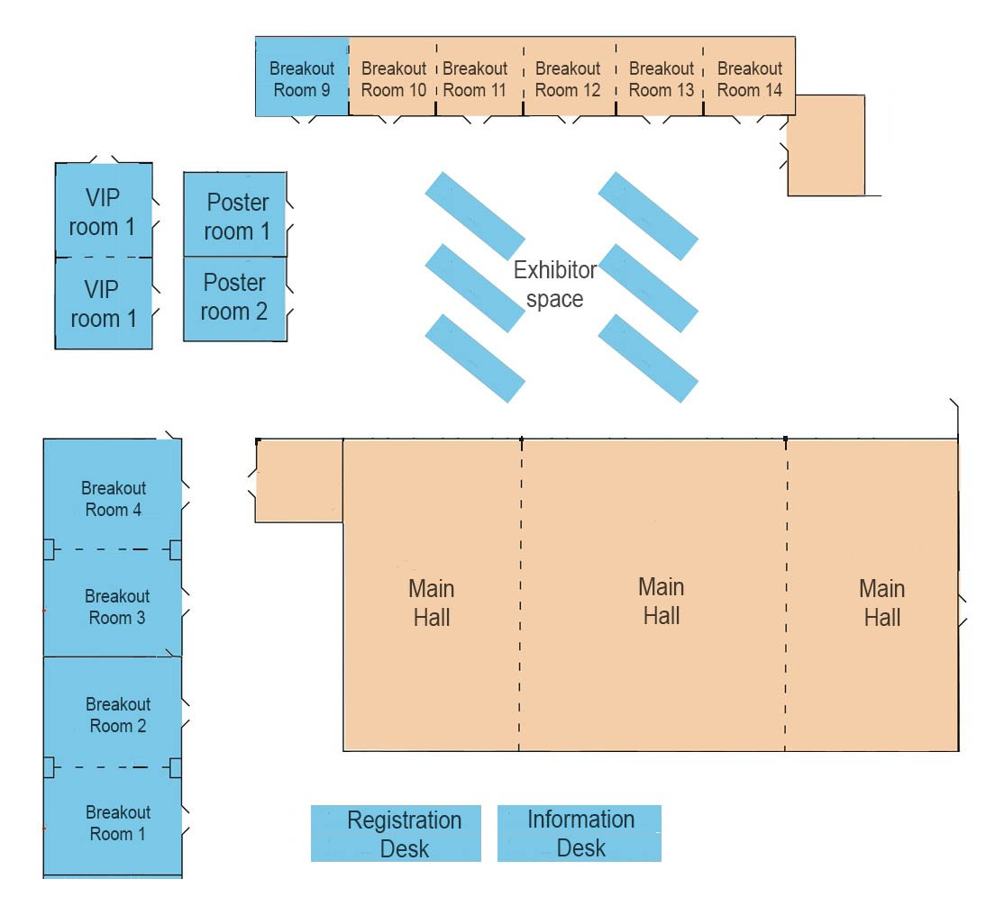

LOCATION

ADDRESS
Panepistimiou 30,
106 79 Athens, Greece

STREET MAP

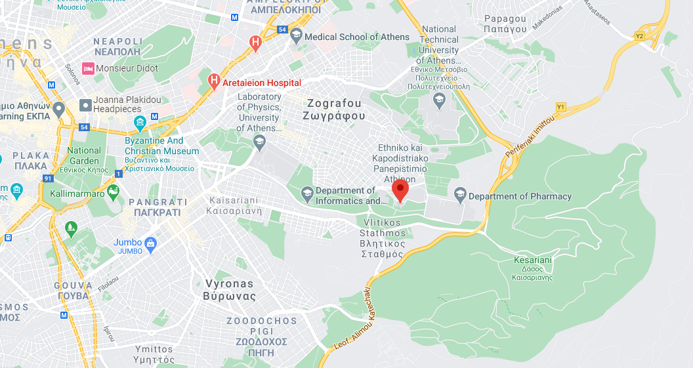
SPEAKERS 1
JAN BLOMMAERT

Biography
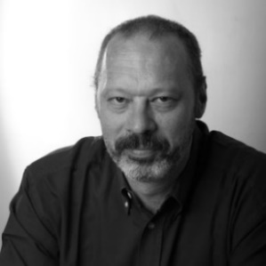

Department of Culture Studies
Tilburg University
The Netherlands

Jan Blommaert is Professor of Language, Culture and Globalization, and Director of the Babylon Center at Tilburg University, the Netherlands. He is of the world’s most prominent Sociolinguists and Linguistic Anthropologists, and has contributed substantially to sociolinguistic globalization theory, focusing on historical as well as contemporary patterns of language and literacy, and on lasting and new forms of inequality emerging from globalization processes.

Invisible Lines in the Online-Offline Linguistic Landscape
This Keynote speech discusses online links to linguistic landscapes. Such links (websites, Facebook, Twitter etc.) feature inscriptions, shop signs and announcements in public spaces. The backdrop for this is our growing awareness that superdiversity analysis requires attention to the online offline nexus defining much of contemporary social life.

SPEAKERS 2

ALEXANDRA GEORGAKOPOULOU

Biography

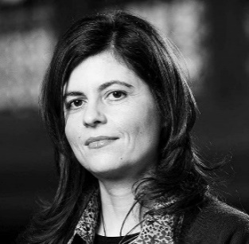

Centre for Language, Discourse and Communication
King’s College London
England

Alexandra Georgakopoulou is a narrative and discourse analyst with a longstanding interest in how people present themselves and relate to others in significant socialization contexts (family, friendship groups, school, leisure sites, social media platforms). Drawing on sociocultural linguistic and interactional perspectives, she has researched the role of everyday life stories (both face-to-face and on new/social media) in the (re)formation of social relations. She has specifically researched, with ethnographic methods, female adolescent peer-groups, in Greece and in London.
Mobilizing small stories on social media
In the keynote, Professor Georgakopoulou will critically interrogate the designing spree of stories as specific features on social media platforms. She will present these directives and discuss their implications for how young people globally, the so-called Generation Z, are socialized into narrating their lives and into making sense of themselves.
SPEAKERS 3

DIMITRIS DALAKOGLOU
Biography
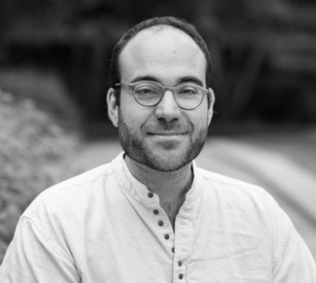

Department of Social Anthropology
Vrije University
The Netherlands

Dimitris Dalakoglou is Professor at Vrije University Amsterdam, where he holds the Chair of Social Anthropology. Since 2004 he is developing an anthropology of material infrastructures which most recently culminated to his current project infra-demos that studies democracy and infrastructures in Greece. He is director of the Lab on Mobility, Infrastructures, Sustainability and Commons (MISC Lab).
The Language of Commons at the age of Infrastructural Gap
From the time of the 2008 Greek crisis, the West has faced an unrepresented infrastructural gap. This gap will become intensified and explicit in subsequent crises. Since 2008, we have sought solutions in the domain of commons and social solidarity. As such, we draw from resources that belong a priori to the realm of commons, such as language acquisition and its use. In this keynote, I will explore ideas about commons and language based on ethnographic research in Greece within the context of my project 'infra-demos.'

PUBLISHING

PROCEEDINGS BOOK

SPECIAL ISSUE (HIGHLY TIERED) JOURNAL PUBLICATIONS

MEDIA PUBLICATIONS

TOP TIER PUBLICATIONS

‘7 steps to acceptance and publishing’

- Proposal submission
- Collaborative development
- Blind review process
- Revision by The GLOCAL COMELA and submitter, and proposal resubmission
- Development of papers by submitters with The GLOCAL COMELA
- Submission of papers to journal publications and publishers.
- Continuous assistance to ensure papers are published

DATES

CHRONOLOGY

Final COVID-19 Call for Abstracts
Opens: October 25, 2020
Closes: March 10, 2021

Notification of acceptance

Notification of acceptance: No later than March 15, 2021

Registration
Presenters must register by August 1, 2021, to guarantee a place in the program. Registration will remain open after this, but organizers cannot guarantee placement after this.

CONFERENCE DATES
Day 1: Wednesday, July 21, 2021
Day 2: Thursday, July 22, 2021
Day 3: Friday, July 23, 2021
Day 4: Saturday, July 24, 2021 - Full day optional anthropological tour (separate cost)

SCHEDULE
Time |  | Wed. 21st July |  | Thurs. 22nd July |  | Fri. 23rd July |  | Sat. 24th July
07:00 |  | Registration |  |  |  |  |  | Anthropological Excursion
08:30 |  | Opening |  | General Sessions / Colloquia |  | General Sessions / Colloquia
10:00 |  | Break |  | Break |  | Break
10:30 |  | Plenary |  | Plenary |  | Whistle Community Demonstration
12:00 |  | Lunch |  | Lunch |  | Lunch
01:30 |  | General Sessions / Colloquia |  | General Sessions / Colloquia |  | General Sessions / Colloquia
03:00 |  | Break |  | Break |  | Break
03:30 |  | Workshop |  | Workshop |  | Workshop
5:00 |  | General Sessions / Colloquia |  | General Sessions / Colloquia |  | Closing
 |  |  |  | Break
7:00 |  |  |  | Dinner

SUBMISSIONS

LENGTHS
- Colloquia – 1.5 hours with 3-5 contributors (Part A and B is possible, thus 6-10 contributors)
- General paper sessions – Approx. 20-25 minutes each, which includes 5 minutes for questions/responses
- Posters – to be displayed at designated times throughout The GLOCAL COMELA 2021
GUIDELINES
- Submission of proposals for papers, posters, and colloquia should be completed via the online submission website, or by email
- 18-word maximum presentation title
- 400-word maximum abstract, including references
- Colloquia: Abstracts for the colloquium must be uploaded in the submissions box. The abstract must contain both the main description of the colloquium, as well as a summarized description of each individual paper to be presented within the colloquium. This information must include the names and affiliations of each author and presenter, the title of each respective session/presentation, as well as any other information construed as relevant.
- General Sessions: For individual papers submitted for review and acceptance into the general sessions, the first author will be the nominated ‘Corresponding Author’, but can also be a ‘Presenting Author’ when completing the profile.
- Each author must also confirm their role: Presenting Author, Non-Presenting Author, Chair, or Discussant.

EVALUATIONS
Proposals for individual papers, posters, and colloquia will be evaluated by The GLOCAL COMELA 2021 Review Committee, with criteria as follows:
- Appropriateness and significance of the topic to the GLOCAL COMELA 2021 themes
- Originality/significance/impact of the research
- Clarity/coherence of research concerns, theoretical and analytical framework(s), description of research, data collection, findings/conclusions, rhetoric, and exegesis as a whole
- For colloquia, importance/significance of the overarching topic and/or framework(s) addressed, and its coherence of and with individual presentations
- All Main Colloquium abstracts only will be peer reviewed by The GLOCAL COMELA 2021 review committee. Thus, the acceptance of the colloquium, and hence all presentations and discussions within that colloquium, becomes predicated on the success of the review of the main proposal for that colloquium, submitted by the main organizers of the respective colloquium.
All abstracts for general session papers, which are selected and placed by The GLOCAL COMELA 2021 selection committee, will be double blind reviewed.
- A participant may be first author/presenter in a maximum of two presentations, be it individual papers, posters, or papers within colloquia.
- In addition, a participant may act as chair, discussant, or co-author in one further presentation.
SUBMISSIONS

EVALUATIONS
- Alternatively, participants may act as first author/presenter in one presentation, and chair, discussant, or co-author in a maximum of two other presentations.
- All proposals must present or interpret original work otherwise yet unavailable.
- The language of The GLOCAL COMELA is English. However, abstracts may be submitted in any language, but together with an English translation.
- Presenters can present in any language, but must prepare an English translation for the presentation.
- The GLOCAL COMELA Committee will assign all relevant schedules to accepted individuals and groups.
- Presenters must register and pay prior to April 1, 2021, to confirm their place at The GLOCAL COMELA 2021, and hence for their presentations to be confirmed in the program.
- Presenters are required to organize their own travel and accommodation arrangements. The GLOCAL COMELA Organizers have secured accommodation at various locations around the city (see link for accommodation), details of which will be available for booking when registering for the GLOCAL COMELA.

PRESENTATIONS

COLLOQUIA

- 1.5 hours with 3-5 contributors
- Colloquia provide an opportunity for several presenters within the boundaries of a theme or topic to present together in a supportive environment. Colloquium organizers can tailor time lengths to each presentation, but must allow time to include opening and closing remarks, presentations, and audience interaction.
- The colloquium chair is responsible for organizing the group and for submitting the colloquium in the Call for Papers platform on behalf of all contributors.
- All colloquium submissions must be uploaded to the submission site using the Colloquium Submission Form Template provided.
- Panel organizers here will be responsible for panel chairs. Time keepers will be provided by The GLOCAL COMELA 2021, if needed.

GENERAL PAPERS

    - Paper presentations will be allocated 25 minutes (+ 5 minutes for questions).
    - Time keepers will be provided by The GLOCAL COMELA 2021 if needed.

POSTERS
- Posters will be displayed at designated times throughout The GLOCAL COMELA 2021.
- Posters are for one-on-one discussion of a symposium-related theme or topic.
- A block of time will be allocated for presenters to discuss their posters.
- Posters will be displayed in the designated areas (main halls).
- Presenters will be assigned a space to display their poster(s).
- Posters should be A0: 841 x 1189 mm width x height (landscape or portrait).
- A guiding but not necessary template for the poster can be found at the link https://glocal.soas.ac.uk/poster-template/
- Submissions should contain a summary of key elements for the presentation.
- Posters can include relevant visuals or academically descriptive objects, where color is optimal.
- Posters must be clear, concise, and simple, with large fonts, with the title of the project, and author information (name and affiliation).
For submission / registration, please visit: https://comela2021.uoa.gr
For all information, please contact:

Ms. Anastasia Tsantes
Communications Liaison, GLOCAL COMELA 2021
comela2021@comela.me
FEES

MAIN
Early Bird $220
Regular Bird $270
Late Bird/On-site $320

STUDENTS / AFFILIATES
Early Bird $170
Regular Bird $220
Late Bird/On-site $270

EXCURSION

Flat fee: $110

Note: The Conference fee includes a daily buffet lunch, morning and afternoon break refreshments, and one buffet dinner with a cultural performance.

INDEXING

TOP TIER PUBLICATIONS

- Through our official Publishing partner, Elsevier, Taylor and Francis, the world’s leading Academic Publisher, The GLOCAL COMELA now has pathways to publish academic material, and to assist contributors and authors to be placed in globally highly ranked publication channels, and in Top Tier SCOPUS / ISI / AHCI / SSCI journals.
- All Conference proceedings, and conference papers and their authors will be SCOPUS indexed
- The GLOCAL COMELA boasts its adherence to, and dedication to, publishing all quality papers.
- A thorough review process will ensure that all participants active in developing their studies and involvement with The GLOCAL COMELA will be published, as The GLOCAL COMELA collaborates with these participants and presenters to revise, redraft, and develop their work.
- All publications will be in Top tier journals, and will thus be decided on by appropriate review procedures, both by The GLOCAL COMELA Materials Review Committees, and by the respective journals to which these will be published.
- The GLOCAL COMELA is a Non-Profit Organization, and all publishing is FREE. The GLOCAL COMELA refuses to implement a pay to publish system, and will always endorse a meritocratic environment for academics, thus refusing to accept any work that requires the implementation of paid fees. Furthermore, The GLOCAL COMELA will always source funding and grants from funding agents to assist those who need funding to access Linguistic Anthropology.

SCIENTIFIC COMMITTEE

SELECTED MEMBERS

Alessandro Duranti – University of California, U.S.A.
Aditi Bhatia –Polytechnic University of Hong Kong, Hong Kong
Aditi Ghosh –Calcutta University, India
Adrian Pablé –University of Hong Kong, Hong Kong
Alexander Coupe – Nanyang Technological University, Singapore
Alice Mitchell – University of Cologne, Germany
Amanda Weidman – Bryn Mawr College, U.S.A.
Ana Deumert – University of Capetown, South Africa
Andreas Stoffers – University of Malaya, Malaysia
Andrea Hoa Pham – University of Florida, U.S.A.
Andrew Wong – California State University, U.S.A.
Anna De Fina – Georgetown University, U.S.A.
Anne Pauwels – SOAS, University of London, U.K.
Asmah Haji Omar – University of Malaya, Malaysia
Barbara Watson Andaya – University of Hawai’i, U.S.A.
Bjarke Frellesvig – University of Oxford, England
Bruce Connell – York University, Canada
Brigittine French –Grinnell College, U.S.A.
Cécile Vigouroux – Simon Fraser University, Canada
Chia-Rung Lu – National Taiwan University, Taiwan
Collette Snowden – University of South Australia, Australia
Collin Williams – Cardiff University, Wales
Daniel Perrin – Zurich University of Applied Sciences, Switzerland
David Katan – University of Salento, Italy
Delia Carmela Chiaro – University of Bologna, Italy
Dimitris Dalakoglou – Vrije University, Amsterdam, Netherlands
Dinh Lu Giang – University of Social Sciences and Humanities, Vietnam
Don Kulick – Uppsala University, Sweden
Eirini Theodoropoulou – Qatar University, Qatar
Fabienne Baider – University of Cyprus, Cyprus
Friederike Lüpke – University of Helsinki, Finland
Geoffrey Benjamin – Nanyang Technological University, Singapore
Ghil‘ad Zuckermann – University of Adelaide, Australia
Gladys Tang – Chinese University of Hong Kong, Hong Kong
Hans Ladegaard – Hong Kong Polytechnic University, Hong Kong
Heather Brookes – University of Capetown, South Africa
Herbert Pierson – Languages & Literatures, St. John’s University, U.S.A.
Howard Giles – University of California, Santa Barbara, U.S.A.
Hugo Cardoso – University of Lisbon, Portugal
Ianthi Tsimpli – Cambridge University, England
Ikuko Nakane – University of Melbourne, Australia
Ingrid Piller – Macquarie University, Australia
Jack Sidnell – University of Toronto, Canada
James Fox – Australian National University, Australia
Jan Blommaert – Tilburg University, The Netherlands
Janet McIntosh – Brandeis University, U.S.A
Jean Michel Filippi – Royal University of Phnom Penh, Cambodia
Jeff Good – University at Buffalo, U.S.A.
Johanna Hanink – Brown University, U.S.A
John Victor Singler – New York University, U.S.A
José Luis Lanata – Nat. Scientific & Technical Research Council, Argentina
Judith Pine – Western Washington University, U.S.A.
Julie Abbou – Aix-Marseille University, France
Julie Faulkner – Monash University, Australia
Katherine Chen – Hong Kong University, Hong Kong
Katherine E. Hoffman – Northwestern University, U.S.A
Kathryn Howard – California State University, U.S.A.
Katrien Pype – KU Leuven University, Belgium
Kendall King – University of Minnesota, U.S.A.
Keren Rice – University of Toronto, Canada
Kira Hall – University of Colorado, U.S.A.
Kristine Horner – University of Sheffield, England
Kuniyoshi Kataoka – University, Japan
Laura Miller – University of Missouri, U.S.A.
Lawrence Reid – University of Hawai’i, U.S.A.
Li Wei – University College London, England
Lionel Wee – National University of Singapore, Singapore
Loretta Kim – Hong Kong University, Hong Kong
Luke Fleming – Université de Montréal, Canada
Mandana Seyfeddinipur – SOAS University of London, U.K.
María Luisa Carrio-Pastor – Polytechnic University of Valencia, Spain
Maisa Taha – Montclair State University, U.S.A.
Mariam Durrani – Harvard University, U.S.A.
Marina Bondi – University of Modena and Reggio Emilia, Italy
Marinus van den Berg – Leiden University, Netherlands
Mark Aldenderfer – University of California, U.S.A.
Mark Alves – JSEALS EIC. Montgomery College, U.S.A.
Mark Turin – University of British Columbia, Canada
Maarten Mous – Leiden University, The Netherlands
Mary Bucholtz – University of California, Santa Barbara, U.S.A.
Matthew Hull – University of Michigan, U.S.A.
Merav Shohet – Boston University, U.S.A.
Michael Lempert – University of Michigan, U.S.A.
Michael Peletz – Emory University, Atlanta, U.S.A.
Michelle Lazar – National University of Singapore, Singapore
Mie Hiramoto – National University of Singapore, Singapore
Momoko Nakamura – Kanto Gakuin University, Japan
Monica Heller – University of Toronto, Canada
Mohsin Khan – Aligarh Muslim University, India
Nana Oishi – University of Melbourne, Australia
Nancy Hornberger – University of Pennsylvania, U.S.A.
Nathan W. Hill – SOAS, University of London, U.K.
Nick Thieberger – The University of Melbourne, Australia
Nishaant Choksi – Kyoto University, Japan
Paja Faudree – Brown University, U.S.A.
Paul Garrett – Temple University, U.S.A.
Paul Sambre – Katholieke Universiteit Leuven, Belgium
Paul Sidwell – Australian National University, Australia
Peter Austin – SOAS, University of London, U.K.
Peter De Costa – Michigan State University, U.S.A.
Pia Pichler – Goldsmiths, University of London, U.K.
Qing Zhang – University of Arizona, U.S.A.
Rachel Harrison – SOAS, University of London, U.K.
Ramy M. K. Aly – American University in Cairo, Egypt
Ritsuko Kikusawa – National Museum of Ethnology, Japan
Rita Kothari – Ashoka University, India
Rizwan Ahmad – Qatar University, Qatar
Robert Amery – University of Adelaide, Australia
Rusty Barrett – University of Kentucky, U.S.A.
Selvyn Jussy – University of Calcutta, India
Shalini Shankar – Northwestern University, U.S.A.
Sharon Carstens – Portland State University, U.S.A.
Sidney Cheung – Chinese University of Hong Kong, Hong Kong
Simon Pickl – University of Cambridge, U.K.
Stephanie Inge Rudwick – University of Hradec Králové, Czech Republic
Steven Thorne – Portland State University, U.S.A.
Susan Needham – California State University, Dominguez Hills, U.S.A.
Suzanne Romaine – University of Oxford, U.K.
Thomas Reuter – University of Melbourne, Australia
Tan Kim Hua – University Kebangsaan Malaysia, Malaysia
Tran Tri Doi – University of Social Sciences and Humanities, Vietnam
Tran Thi Hong Hanh – University of Social Sciences and Humanities, Vietnam
Umberto Ansaldo – University of Hong Kong, Hong Kong
Verita Sriratana – Chulalongkorn University, Thailand
Vina Tsakali – University of Crete, Greece
Vijay Kumar Bhatia – City University of Hong Kong, Hong Kong
William Hanks – University of California, Berkely, U.S.A.
Yahya Asiri – King Khalid University, Abha, Saudi Arabia
Yee-Jean Fon – National Taiwan University, Taiwan
Ying Ying Tan – Nanyang Technological University, Singapore
Yoshiyuki Asahi – Nat. Institute for Japanese Lang. and Ling., Japan
Zane Goebel – La Trobe University, Australia
Zuraidah Mohd Don – University of Malaya, Malaysia
Honorary members

Alexandra Jaffe – California State University
Barbara Johnstone – Carnegie Mellon University
Gunther Kress – University College London
Harry Triandis – University of Illinois

AFFILIATES

SELECTED GLOBAL AFFILIATES

The World Council of Anthropological Associations
Taylor & Francis Publishers Global
Elsevier
Blinn College, U.S.A.
Boston College, U.S.A.
Florida International University, U.S.A.
Hofstra University, U.S.A.
Montclair State University, U.S.A.
Montclair State University, U.S.A.
Ohio State University, U.S.A.
Temple University, U.S.A.
Texas Tech University, U.S.A.
University of Hawai’i at Manoa, U.S.A.
University of Illinois Urbana-Champaign, U.S.A.
University of Kansas, U.S.A.
University of Virginia, U.S.A.
Royal University of Phnom Penh, Cambodia
Paññāsāstra University of Cambodia, Cambodia
Capital Normal University, China
Beijing Normal University, China
Beijing University of Civil Engineering and Architecture, China
Hong Kong Polytechnic University, Hong Kong
Indian Anthropological Society, India
Calcutta University, India
Jadavpur University, India
Nalanda University, India
Shekhawati Public School, India
Shekhawati Engineering College, India
Airlangga University, Indonesia
University of Indonesia, Indonesia
Aichi University, Japan
Tunku Abdul Rahman University College, Malaysia
University of Malaya, Malaysia
Universiti Putra Malaysia, Malaysia
University College Berjaya, Malaysia
University of Sindh, Pakistan
Quaid i Azam University, Pakistan
Nanyang Technological University, Singapore
Hankuk University of Foreign Studies, South Korea
University of The Philippines, The Philippines
National Chengchi University, Taiwan
National Donghwa University, Taiwan
National Taiwan University, Taiwan
Thammasat University, Thailand
Khon Kaen University, Thailand
Vietnam National University, Vietnam
Vietnam National University, Vietnam
Institute of Cultural Studies, Vietnam
Vietnamese Folklore Association, Vietnam
University College London, U.K.
University of London, U.K.
SOAS University of London, U.K.
University of East Anglia, U.K.
American College of Greece, Greece
Demokritus University of Thrace, Greece
University of Bologna, Italy
Università Cattolica del Sacro Cuore, Italy
International University of Languages and Media, Italy
University College Dublin, Ireland
University of Groningen, Netherlands
University of Bucharest, Romania
University of Salamanca, Spain
Polytechnic University of Valencia, Spain
Stockholm University, Sweden
The American University in Cairo, Egypt
MSA University, Egypt
University of Ghana, Ghana
Kwame Nkrumah University of Science and Technology, Ghana
University of Nairobi, Kenya
Covenant University, Nigeria
University of Lagos, Nigeria
Ahmadu Bello University Zaria, Nigeria
University of Dar es Salaam, Tanzania
Uganda Christian University, Uganda
Makerere University, Uganda
Midlands State University, Zimbabwe
University of Western Australia, Australia
Monash University, Australia
University of South Australia, Australia
The University of Adelaide, Australia
Qatar University, Qatar
Princess Nourah Bint Abdul Rahman University, Saudi Arabia
COVID-19

STATEMENT

The (SCOPUS/ISI) GLOCAL COMELA 2021 will be held on July 21-24, 2021, at The National and Kapodistrian University of Athens, in Athens, Greece.
The past year has seen the COVID-19 affect the world as a pandemic unprecedented in modern time, and has forced a change in lifestyle, economy, law, and academic and educational approaches. It is everyone’s hope that solutions are immediately found to the adverse consequences of COVID-19, and The (SCOPUS/ISI) GLOCAL COMELA is at the fore of efforts to seek solutions. It is The GLOCAL COMELA’s responsibility to disseminate information on the Sociological and Anthropological aspects of the virus and its effects on global society. It is also The GLOCAL COMELA’s hope that the virus is eradicated immediately, and with minimized devastation.
The (SCOPUS/ISI) GLOCAL COMELA 2021 in Greece on July 21-24, 2021 must be at a time when the COVID-19 virus has been fully contained and eradicated, and when we can look back and see the virus as a past occurrence, while we again live as we did prior to the virus, but with new knowledge, knowing that we can once again interact with freedom. The GLOCAL COMELA 2021 aims to be central in both the understanding and the application of these new global networks, where people globally interact to engage in academic thought and praxis. We are fully optimistic that The GLOCAL COMELA 2021 conference will be at a time when people will again walk and interact in freedom, and not in patent fear of sickness and even death due to the virus. The conference will be, we are certain, at a time when we as a world, have grown significantly to realize the benefits of social interaction, the difficulties of isolation, and new ways of applying knowledge so as to resolve and even counter adversities that alter our lifestyles.
The world was not fully prepared to leave its face to face interactivity, and to be forced to operate solely through the medium of technology, but we have learnt. We have had to opt for the yet insufficient interconnectivity and to make do with what we have, so as to resolve medical and political stringencies, and to maintain our level-headedness. It is no overstatement that governments, at many times rightly so, have enforced very strict laws, to maintain the safety of global societies, and to attempt to control the COVID-19. However, the avenues through which to control the virus have still been limited, and these include academic scholarly work. Here, The (SCOPUS/ISI) GLOCAL COMELA, as a fully non-profit organization, comes in, by ensuring that scholarship does tackle the virus, and pandemics such as this, as well as other issues that seek to adversely change our lifestyles, but with the knowledge that one day, we will have developed immensely as a society, and as the human race. We now can look back and view our trajectory as a global society and can reflexively view ourselves as a grown humanity, the maturation of which has been a forced one, but a beneficial one nonetheless.
Throughout the past year, most if not all of the world has spent a substantial amount of time assessing factors that range from the blatant, such as economy, health, and confinement, to the implicit such as self-worth, implied arrogances and benevolences, and the reality of a technologically mediated society and how it will alter our beings as a human society. We have had to reassess our histories and futures, throughout this period, and to come to terms with our potentials as the human race, only to realize that while we do have immense potential to evolve, in a short space of time, we also have limited capacities, which can be overcome, through knowledge and through truths. As such, one lesson we have learnt through the virus pandemic is that, without truths, we suffer as a global society, and not in specific regions only;
COVID-19

STATEMENT

should one part of the world conceal, distort, or fabricate the truth, we all suffer and must compensate for this deceit.
The processes of the world are neither fully circular, linear, nor random and haphazard. They are replete with semiotic abundances that have their own sets of dynamics, their own symbolisms, and their own agencies through which we are required to comply at times. These scapes affect us all, and require us to both conform to their agencies, and to try to negotiate global processes so as to ultimately have them conform to our needs. It is wrong to make positivist and simplistic statements such as that we are seeing circular processes, or linear processes, or random processes, and we must come to terms with this, if we are to counter the COVID-19, other pandemics, and other crises. There are mechanisms at work both natural and man-made, which we must awaken to, and which we must tap into in order to resolve issues of plaguing humanity. We have an aversion to change, but we must awaken to change, and to embrace it, whether circular, linear, or random. Concurrently, we must learn to accommodate to altered spatialities and temporalities, such as the increased spaces that regulate our socializations, and the accelerated usage of time emerging from our panicked states and from our being bombarded by new technologies.
We do as we can, and as we are prepared to do, but we can do much more, as a humanity working in unison, yet as individuals with our own insecurities and agencies. We are a human race that seeks to explore the world, the cosmos, and yet the inner human, through the many strands that have evolved in what we call science, humanity, and spirituality. The (SCOPUS/ISI) GLOCAL COMELA is at the centre of Anthropological work in these explorations, and is working with the world, to solve the COVID-19 crisis, to contend with forces both positive and adverse, and to effect positive shifts, the world over.

The GLOCAL Central Committee

CONTACT

Ms Anastasia Tsantes
Communications Coordinator
GLOCAL COMELA 2021
comela2021@comela.me
cala@soas.ac.uk
https:// comela2021.uoa.gr
https://comela2021.uoa.gr/submit
https://comela2021.uoa.gr/reg
https://soas.academia.edu/GLOCALSOAS
https://facebook.com/thecomela

